James Moran

This report is a reflection of our team’s development process of the Game Café System. This report details the design, development, testing and reflection of the project, among other aspects.

Development Report

Software Systems Development (AE2)

Contents

**No table of contents entries found.**

# List of Tables

**No table of figures entries found.**

# List of Figures

**No table of figures entries found.**

# Elicitation of Requirements

For the elicitation of requirements (Requirements Gathering), there is the base set of what the User would (most likely), want from the system:

Membership related information:

* Membership types: Bronze, Silver, Gold
* PEGI Age group: 12, 16, 18

Bookings:

* Hardware: PC / Xbox One / PlayStation 4
* Date & Time / Duration
* Prices

Game Software:

* Chart / Classic
* Single / Multi Player
* PEGI Age group: 3, 7, 12, 16, 18

eSports Events:

* Date & Time
* Number of Tickets

The Game Café is likely to want to perform the following tasks:

* View/Add/Update/Maintain membership information
* View/Add/Update/Maintain booking information
* View/Add/Update/Maintain eSports event information
* Associate bookings with both members and non-members and hardware/software as appropriate
* Associate eSports event tickets with members

The prices for sessions are:

* Members: 1hr £1.50 / 2hr £2.50 / 5hr £4.00
* Non-member supplement: £0.50

Along with the Game Café System, holding records of Membership details, such as name, address, telephone number, date of birth (if younger than 18 years of age) and the type of membership. This information must be encrypted in the production version of the Game Café System, but such encryption is not necessary in the prototype (but there should at least be a plan for encryption). In addition, the Game Café System is to hold details for eSports Events.

From these base requirements, a Mind Map of what the system must have, can be formed. Our project’s Mind Map Is shown below:

Figure 1: The base Game Cafe Mind Map, based on the requirements noted on the previous page.

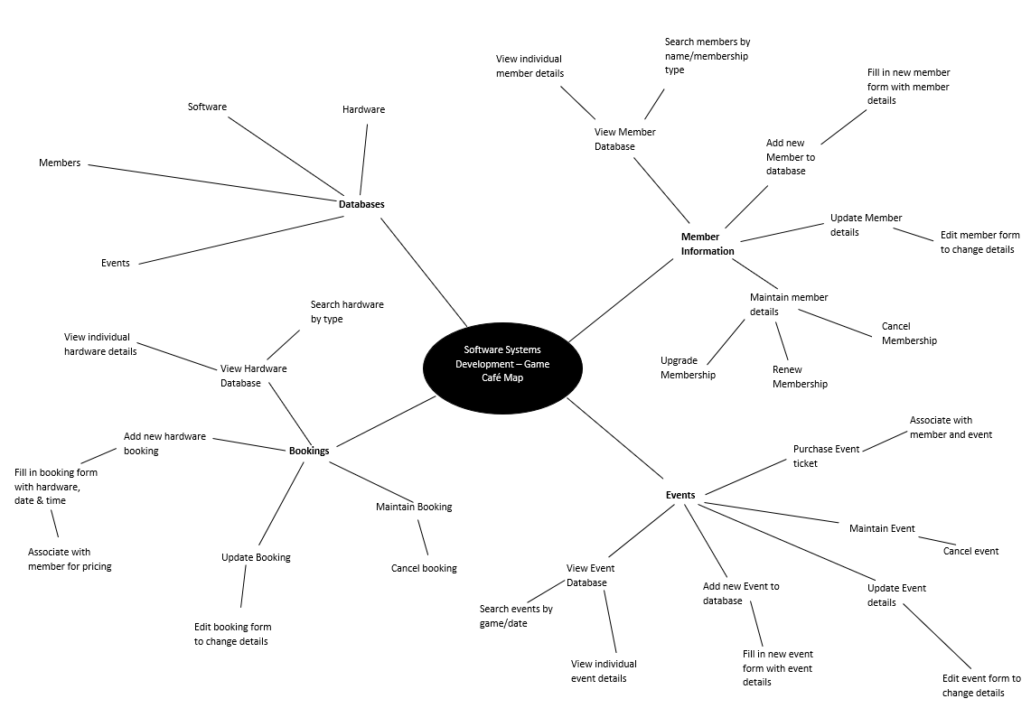

# Analysis of Requirements

# Expression of Requirements

# The Use of SCRUM in Our Team

# Project Design

# Project Development

# Testing the Project

# Integrating the Project

# Refactoring for the Project

# Configuration Management/Version Control